|  |  |  |
| --- | --- | --- |
|  |  |  |
|  |  | STEELMANS PUBLIC SCHOOL |
|  |  | 1630372 |
|  |  | 20364 |
|  |  | STEELMANS PUBLIC SCHOOL , PATIALA -SANGRUR ROAD , CHANNO -148026 |
|  |  | ANJALI GAUR |
|  |  | M.COM, M.A, B.ED. |
|  |  | [channosteelmans@gmail.com](mailto:channosteelmans@gmail.com) |
|  |  | 9888451930 |

|  |  |  |
| --- | --- | --- |
|  |  |  |
|  |  | https://steelmansschool.com/wp-content/uploads/2025/02/AFFILIATION-EXTENSION-LEETER.pdf |
|  |  | https://steelmansschool.com/wp-content/uploads/2025/02/CERTIFICATE-OF-REGISTRATION-OF-SOCIETIES.pdf |

|  |  |  |
| --- | --- | --- |
|  |  | https://steelmansschool.com/wp-content/uploads/2025/02/NOC-CERTIFICATE.pdf |
|  |  | https://steelmansschool.com/wp-content/uploads/2025/02/RTE-RECOGNITION-CERTIFICATE.pdf |
|  |  | https://steelmansschool.com/wp-content/uploads/2025/02/Building-Safety-certificate.pdf |
|  | COPY OF FIRE SAFETY CERTIFICATE | https://steelmansschool.com/wp-content/uploads/2025/02/Fire-safety-certificate.pdf |
| 7 |  | https://steelmansschool.com/wp-content/uploads/2025/02/Water-Testing-Report-1-8.pdf |

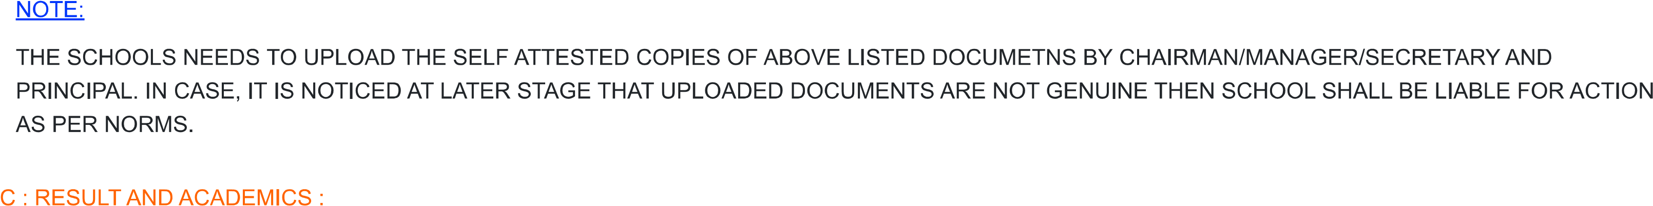

|  |  |  |
| --- | --- | --- |
|  |  |  |

|  |  |  |
| --- | --- | --- |
|  |  | https://steelmansschool.com/wp-content/uploads/2025/02/FEE-STRUCTURE.pdf |
|  |  | https://steelmansschool.com/wp-content/uploads/2025/02/ACADEMIC-CALENDER.pdf |
|  |  | https://steelmansschool.com/wp-content/uploads/2025/03/SCHOOL-MANAGING-COMMITTEE-2.pdf |
|  |  | https://steelmansschool.com/wp-content/uploads/2025/02/List-of-PTA.pdf |
|  |  | https://steelmansschool.com/wp-content/uploads/2025/02/Last-Three-Years-Result.pdf |

|  |  |  |
| --- | --- | --- |
|  |  |  |
|  |  | MRS. ANJALI GAUR |
|  | |  |  | | --- | --- | |  | 41 | |  | 10 | |  | 18 | |  | 13 | | |
|  |  | 1:3 |

|  |  |  |
| --- | --- | --- |
|  |  |  |
|  |  |  |

|  |  |  |  |  |  |
| --- | --- | --- | --- | --- | --- |
|  |  |  |  |  |  |
|  | 2024 | 64 | 60 | 94 |  |
| 2. | 2023 | 69 | 69 | 100 |  |
| 3. | 2022 | 62 | 62 | 100 |  |

|  |  |  |  |  |  |
| --- | --- | --- | --- | --- | --- |
|  |  |  |  |  |  |
| . | 2024 | 71 | 66 | 92 |  |
| 2. | 2023 | 63 | 61 | 97 |  |
| 3. | 2022 | 60 | 60 | 100 |  |

|  |  |  |
| --- | --- | --- |
|  |  |  |
|  |  | 16187 |
|  |  | 45 & 36 |
|  |  | 4 & 58 |
|  |  |  |
|  |  | 16 |

|  |  |  |
| --- | --- | --- |
|  |  | 30 |
|  |  |  |